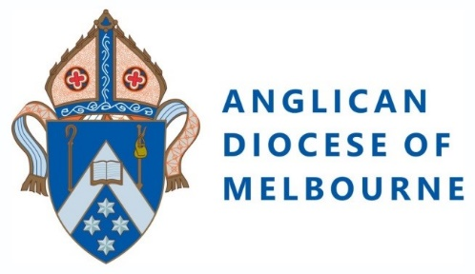

Parish Child Safety Officer

Parish Child Safety Officer: [Name]
Parish Name: [insert Parish name here]
Reports To: [Vicars name here]
Parish Warden: [Wardens name here]
Prepared By: Anglican Diocese on Melbourne

Summary
The role of the Parish Child Safety Officer is to promote safety within their parish or congregation and to provide support, encouragement and help to manage risk and to maintain a safe community for all children and vulnerable people. The Parish Child Safety Officer undertakes all aspects of Safe Ministry in the Church community, ensuring that the prescribed process for safe ministry is followed.

Key Responsibilities:

- Understanding the Church’s Code of Conduct for Child Safety and Wellbeing.
- Liaise with the Vicar and Parish Council and other safety officers (including PVAW champions) to foster a culture of safety within the parish or congregation.
- Be the point of contact in the parish or congregation for a person to raise concerns about child safety.
- Facilitate the reporting to Police or Child Protection and then to Kooyoora, the Director of Professional Standards, any conduct or environment that does not meet the standards prescribed in Faithfulness in Service and Code of Conduct for Child Safety and Wellbeing.
- Be a source of support and advice to parents, children, the Vicar, Parish Councils and parishioners in the area of child safety.
- Undertake all aspects of the Safe Ministry and Child Safety & Wellbeing policies, ensuring that the prescribed processes for child safety is followed.
- Ensure that the Safe Ministry and Child Safety & Wellbeing policies and related documentation is available publicly.
- Ensure all people participating in the life of the church community are aware that reporting of suspected abuse or neglect must be made and the role of the Parish in this.
- Act as a source of support, advice and expertise to clergy, office holders, volunteers and parishioners on matters of safe ministry.
- Collaborate with the Parish and Diocese and Kooyoora to create a culture of safety.
- Report any inappropriate behaviour through appropriate channels, these being Victoria Police, Child Protection and Kooyoora, depending on the severity and urgency of the matter.

Critical Relationships:

The Parish Child Safety Officer will report directly to the Vicar and Parish Council. They will maintain relationships with the Anglican Diocese of Melbourne and Kooyoora. They will provide direct support with those involved in child-related work in the Parish as well as frequent contact with Parishioners/Church members.

Qualifications and/or Experience:

- Understanding of child safety and safe ministry.
- Familiar with the Anglican Church and a practical understanding of its ethos would be ideal.
- Excellent administrative skills.
- Working knowledge of database management.
- Basic standard of Word processing.

Personal Qualities:
- Friendly personality.
- Self-motivated with ability to set own priorities and deadlines.
- Able to take direction as well as lead teams.
- Good communication skills.
- Ability to maintain confidentiality.
- Excellent people and communication skills.
- Excellent record keeping.
- Teamwork.
- Attention to detail.

Parish Child Safety Officer: ________________________________________________________________
(Signature)
Parish Warden: _______________________________________________________________________________
(Signature)
Vicar/Senior Minister: _______________________________________________________________________
(Signature)
Date: ____________________________________________
(Date)

